Sunday 29th July 2018 – Ninth Sunday after Trinity

TODAY’S SERVICES
8.00am Holy Communion at St Thomas’
9.15am Holy Communion at St Thomas’ Hymns: A&M 394, 451, 453, 652
9.15am Service of the Word at St George’s Hymns as Announced
11.00am Holy Communion at St Bartholomew’s Hymns: A&M 394, 451, 453, 652 Communion: 430, 794

- We welcome everyone to worship today; if this is your first time with us, please introduce yourselves to the clergy, wardens or sidespeople
- During the Administration of Holy Communion we keep silence or join with the singing of the communion hymns.
- At communion please come forward following the direction of the sidespeople.to the communion rail.
- Gluten free wafers are available for those who need them. Please mention this to the clergy before the service.
- There are large print service and hymn books available if you need them.
- Coffee is served after all the services (except the 8am service)
- There is an induction loop at St. Bartholomew’s – please switch hearing aids to the “T” setting

We pray for:
Those who are ill: Irene Booth, Christopher Davies, Lisa Ginniff, Jenny Harris, Edith Ibbotson, Patricia James, Ailsa Maddison, Eileen Marsh, Kath Morris, James Wright, Mohammad Ali Zane.

Those who have died recently: Sandra Isherwood

And on their anniversaries this week, we remember: Brian Clare, James Crompton, Lena Hodgkiss, Sarah Hollingsworth,
Jean Hope, Clarice Pomfret, Doris Westby, Ida Wood.

This week: Please take away this pewsheet and the and the monthly newsletter and prayer diary for August

Wednesday 1st August: Holy Communion 10.00am at St Bartholomew’s.

Saturday 4th August: We pray for David Andrew Scully & Danielle Amanda McClurg being married today at St. Bartholomew’s church at 12:00 noon.

Coming Up in July / August:

Urban Aid Lunches: Urban Aid are once again providing packed lunches for children who may not otherwise get a meal during the school holidays. If anyone is available to help, either on a regular basis or as a one-off, the lunches will be made up every morning, Monday to Friday until 31st Aug (excl Bank Holiday Mon 27th Aug) from 7am - 8.30am. The location is the former Baptist Church, Snowden Street, Bolton, BL1 2PU.

We pray for those being married at St. Bartholomew’s:

George Harold Kirkwood & Gillian Crank [18th August 2pm]

Liam Paul Balmer & Camilla Jayne Dale [1st September 3:00pm]

St. Bartholomew’s choir is recruiting. Anyone who likes singing and is available for the Wednesday rehearsals at 7:30pm, please see Ed.

August “Organ Pops” Month at St. Bart’s: next Sunday we start with every piece you know by J S Bach including “Jesu, joy of man’s desiring,” “Sheep may safely graze” ending with the infamous Toccata & Fugue in d minor [BWV565]. Elgar, everything French and Handel in the weeks after.

St. Thomas – apologies, but we’re unable to provide refreshments after the morning service during the school holidays while reflooring work is carried out in the kitchen.

St. Bartholomew’s Day will be marked on Sunday 19th August. The 11:00am service at St. Bartholomew’s will be followed by a “Bring-and-Share” buffet lunch to which everyone is welcome to stay. The idea is that we all bring some food which is pooled and shared. There are sign-up sheets out so that we know what everyone is bringing [we can’t have everyone bringing truffle-infused lobster!]
Please note that this will be Ian Hepburn’s last Sunday with us before he moves to Bolton Parish Church to continue his training period with Canon Chris Bracegirdle.
It’s also Kirsty’s final Sunday before starting her maternity leave.

Social Media: Currently Kirsty runs and updates both the Facebook and Twitter pages for the parish. Both pages are popular with regular interactions and are a great way of sharing information and what’s happening in the parish. While on maternity leave, and thinking further ahead, Kirsty is looking for support in keeping the pages updated. Therefore: 1) If anyone who is interested in becoming an admin member for one or both the pages please speak to Kirsty. 2) If you have an event that’s happening for advertisement / has happened please share information either by e-mail or through private messages on either / both pages for this to be shared (please just make sure that any photos taken do have permission for social media use). If we don’t get told, we can’t promote and share what’s been happening.

The Collect:
Gracious Father, revive your Church in our day,
and make her holy, strong and faithful, for your glory’s sake in Jesus Christ our Lord. Amen.

First Reading: 2 Kings 4. 42 - end
⁴²A man came bringing food from the first fruits to Elisha, the man of God: twenty loaves of barley and fresh ears of grain in his sack. Elisha said, ‘Give it to the people and let them eat.’ ⁴³But his servant said, ‘How can I set this before a hundred people?’ So he repeated, ‘Give it to the people and let them eat, for thus says the LORD, “They shall eat and have some left.”’ ⁴⁴He set it before them, they ate, and had some left, according to the word of the LORD.

New Testament Reading: Ephesians 3. 14 - end
¹⁴I bow my knees before the Father, ¹⁵from whom every family in heaven and on earth takes its name. ¹⁶I pray that, according to the riches of his glory, he may grant that you may be strengthened in your inner being with power through his Spirit, ¹⁷and that Christ may dwell in your hearts through faith, as you are being rooted and grounded in love. ¹⁸I pray that you may have the power to comprehend, with all the saints, what is the breadth and length and height and depth, ¹⁹and to know the love of Christ that surpasses knowledge, so that you may be filled with all the fullness of God. ²⁰Now to him who by the power at work within us is able to accomplish abundantly far more than all we can ask or imagine, ²¹to him be glory in the church and in Christ Jesus to all generations, for ever and ever. Amen.

Gospel Reading: John 6. 1 - 21
¹Jesus went to the other side of the Sea of Galilee, also called the Sea of Tiberias. ²A large crowd kept following him, because they saw the signs that he was doing for the sick. ³Jesus went up the mountain and sat down there with his disciples. ⁴Now the Passover, the festival of the Jews, was near. ⁵When he looked up and saw a large crowd coming towards him, Jesus said to Philip, ‘Where are we to buy bread for these people to eat?’ ⁶He said this to test him, for he himself knew what he was going to do. ⁷Philip answered him, ‘Six months’ wages would not buy enough bread for each of them to get a little.’ ⁸One of his disciples, Andrew, Simon Peter’s brother, said to Jesus, ⁹‘There is a boy here who has five barley loaves and two fish. But what are they among so many people?’ ¹⁰Jesus said, ‘Make the people sit down.’ Now there was a great deal of grass in the place; so they sat down, about five thousand in all. ¹¹Then Jesus took the loaves, and when he had given thanks, he distributed them to those who were seated; so also the fish, as much as they wanted. ¹²When they were satisfied, he told his disciples, ‘Gather up the fragments left over, so that nothing may be lost.’ ¹³So they gathered them up, and from the fragments of the five barley loaves, left by those who had eaten, they filled twelve baskets. ¹⁴When the people saw the sign that he had done, they began to say, ‘This is indeed the prophet who is to come into the world.’ ¹⁵When Jesus realized that they were about to come and take him by force to make him king, he withdrew again to the mountain by himself. ¹⁶When evening came, his disciples went down to the lake, ¹⁷got into a boat, and started across the lake to Capernaum. It was now dark, and Jesus had not yet come to them. ¹⁸The lake became rough because a strong wind was blowing. ¹⁹When they had rowed about three or four miles, they saw Jesus walking on the lake and coming near the boat, and they were terrified. ²⁰But he said to them, ‘It is I; do not be afraid.’ ²¹Then they wanted to take him into the boat, and immediately the boat reached the land towards which they were going.

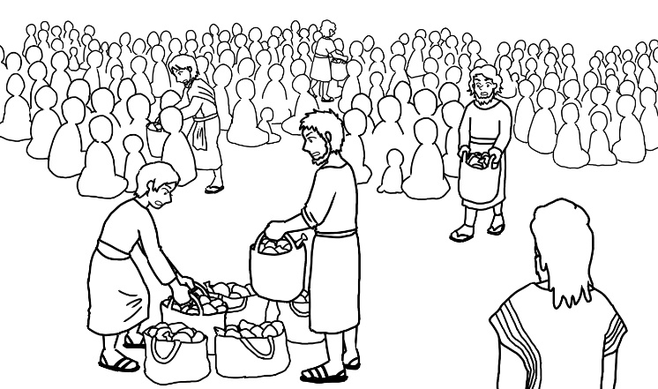

Post Communion Prayer:
Holy Father, who gathered us here around the table of your Son to share this meal with the whole household of God: in that new world where you reveal the fullness of your peace, gather people of every race and language
to share in the eternal banquet of Jesus Christ our Lord.
Amen.

Next Sunday’s Services: Tenth Sunday after Trinity
Readings: 2 Kings 4. 42-end / Ephesians 3. 14-end / John 6. 1-21
8.00am St Thomas’ Holy Communion Revd Angela Wynne
9:15am St Thomas’ Holy Communion Revd Angela Wynne
9:15am St. George Holy Communion Revd Kirsty Screeton
11.00am St Bartholomew Holy Communion Revd Angela Wynne

Team Rector: vacant www.westhoughtonchurches.org.uk
Curate: Revd. Kirsty Screeton – 01942 575383: revkirstyscreeton@gmail.com
Team Vicar: Revd Angela Wynne 01204 468150 – revawynne@gmail.com

FACEBOOK – locate us by searching Westhoughton parish Follow us on twitter @Wparishchurch

Material for the news sheet should be sent to Joan Warner by Wednesday morning 01942 818821 joanwarner35@outlook.com

